**Biological Systems Presentation**

Name:________________________________________

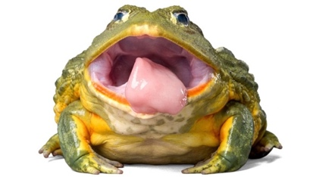Task: Individually, you are to compare and contrast how a body system works in a mammal compared to in an invertebrate. (plant or invertebrate animal).

Chose one of the following options:

* Compare and contrast the **reproductive** system of a **human** with a **flowering plant**
* Compare and contrast the **respiratory** system of a **horse** with an **earthworm**
* Compare and contrast the **circulatory** system of a **whale** with an **octopus**

The focus of this research is to identify the similarities and differences of the chosen system in different organisms and how it helps the organism to survive.   
  
**Include the following key points**:

* The function of the system
* The organs which make up the system
* The structure of an organ in the system and how it functions in system
* The similarities and differences in the system between chosen organisms
* Why are the differences **effective** to help the organism to survive and/or reproduce

You must prepare this assessment in the format of your choice e.g. **PowerPoint presentation.**

.

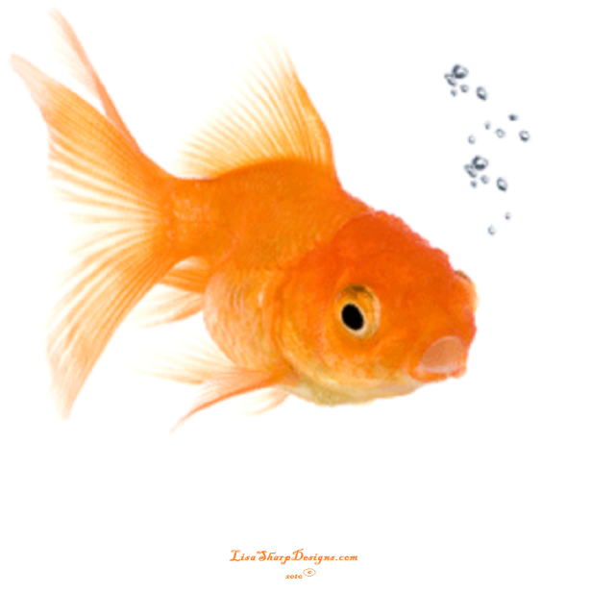

**Biological Systems Presentation**

**MARKING KEY**

Student Name: ___________________________

|  |  |  |
| --- | --- | --- |
| **CONTENT** | Possible marks | Your mark |
| Common (1) and scientific names (1) for the organisms chosen are clearly stated | 2 |  |
| Describes function of system (1), in detail (1) | 2 |  |
| States major organs in the systems present in each organism (2)  Includes a diagram showing the system organs for each organism (2) | 4 |  |
| Describes the structure of two organs (2) in the chosen system for each organism (2) in detail (2) | 6 |  |
| Describe how the structure of one organ in each organism relates to the function of the system (2) in detail (2) | 4 |  |
| State at least two similarities between the system in each organism (2) | 2 |  |
| State at least two differences between the system in each organism (2) | 2 |  |
| State the environment each organism lives in (2) and explain how the differences in each organisms body system helps them to survive in their environment (2) in detail (2) | 4 |  |
| **PRESENTATION** |  |  |
| Correct spelling and grammar | 1 |  |
| Uses simple language (in own words) | 1 |  |
| Visually engaging | 2 |  |
| Uses multiple relevant diagrams/images to support explanation | 2 |  |
| **REFERENCES** |  |  |
| No References given  Includes more than two to three references (1) and in correct format (1)  Includes more than five references (2) and in correct format (2) | 0  2  2 |  |
| **TOTAL** | **36** |  |
|  |  |  |